Sheet 2 - solution - OMAR RASHAD MAHMOUD

#task1
import cv2; import numpy as np
#brg
colored = cv2.imread("colored.jpg",cv2.IMREAD_COLOR)
cv2.imshow("task1-1", colored)
# cv2.destroyWindow("task1-1")
#bgr
blue = colored.copy()
blue[:,:,1] = 0
blue[:,:,2] = 0
cv2.imshow("task1-2", blue)

green = colored.copy()
green [:, : , 0] = 0
green [:, : , 2] = 0
cv2.imshow("task1-3", green)

red = colored.copy()
red [:, : , 0] = 0
red [:, : , 1] = 0
cv2.imshow("task1-4", red)
cv2.waitKey(0)
#task2
import cv2 ; import numpy as np

arr1 = np.zeros((256,256), dtype = np.uint8)

arr1[:127, :127]= 255
arr1[128:255, 128:255]= 255

cv2.imshow("Task2",arr1)
cv2.waitKey(0)
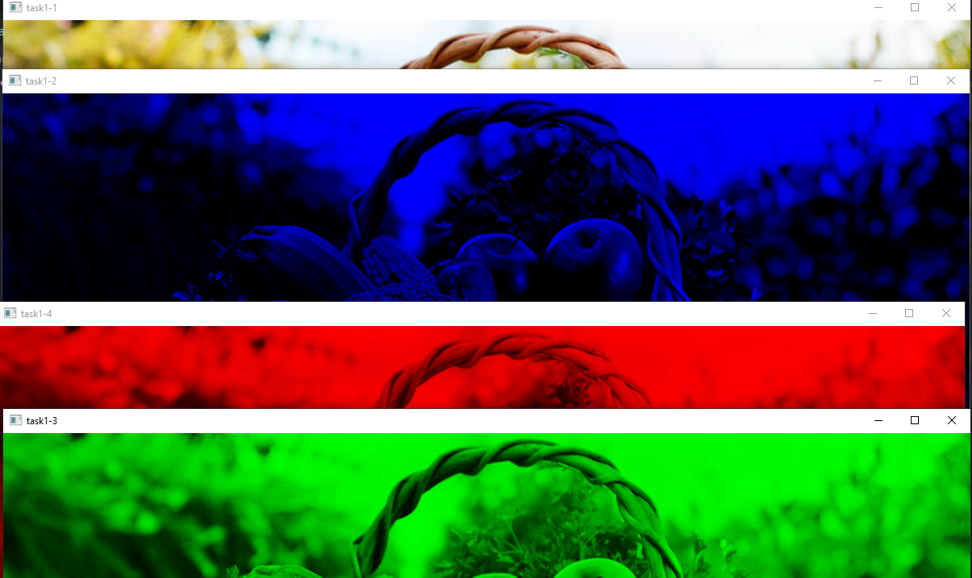

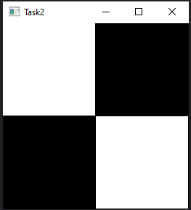
#task2
import cv2 ; import numpy as np

arr1 = np.zeros((256,256), dtype = np.uint8)

arr1[:127, :127]= 255
arr1[128:255, 128:255]= 255

cv2.imshow("Task2",arr1)
cv2.waitKey(0)

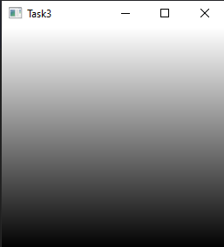

#task3
import cv2 ; import numpy as np
arr1 = np.zeros((256,256), dtype = np.uint8)

for i in range(256) :
arr1[i] = 255 - i

cv2.imshow("Task3",arr1)
cv2.waitKey(0)

#task4
import cv2 ; import numpy as np
before = cv2.imread("sheet2.png" ,0 )

after = np.zeros((before.shape[0],before.shape[1]) , dtype= np.uint8)

for i in range(650) :
for j in range(650) :
after [649 - i,649 - j] = before[ i , j ]

cv2.imshow("task4", after)
cv2.waitKey(0)
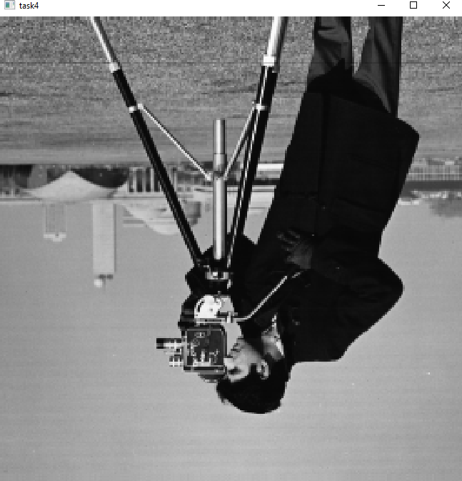

# task 5
import cv2
import numpy as np
before = cv2.imread("sheet2.png", 0)
after = np.zeros((before.shape[0], before.shape[1]), dtype=np.uint8)

for i in range(0, 324):# swap 2 parts on main diagonal
for j in range(0, 324):
after[324 + i, 324 + j] = before[i, j]

for i in range(324, 650):
for j in range(324, 650):
after[-324 + i, -324 + j] = before[i, j]

for i in range(0, 324):#swap 2 parts on auxiliary diagonal
for j in range(324, 650):
after[324 + i, j - 324 ] = before[i, j]

for i in range(324, 650):
for j in range(0, 324):
after[i - 324, j + 324 ] = before[i, j]

cv2.imshow("task 5 ", after)
cv2.waitKey(0)

